Arlington Township
Office phone 269 427 7300
Douglas De Leo, Supervisor
Georgette Peterson, Clerk
Jill Sanborn, Treasurer
Ron Klein, Trustee
Ted Swanson, Trustee

Van Buren County, MI.
52022 34th Ave.
Bangor MI 49013

Agenda is subject to change before Meeting date.

January 17, 2024
07:00p.m.

Call meeting to order:
Pledge of Allegiance and invocation:

Roll Call:
Approve Agenda:

Reports:

Law Enforcement:

Fire Departments:

Commissioners’ Report:

Assessors’ Report:

Approval of December 13, 2023 minutes

Public Comment on any agenda items (3-minute limit)

Supervisors’ Report: Budget Amendments 2023/2024

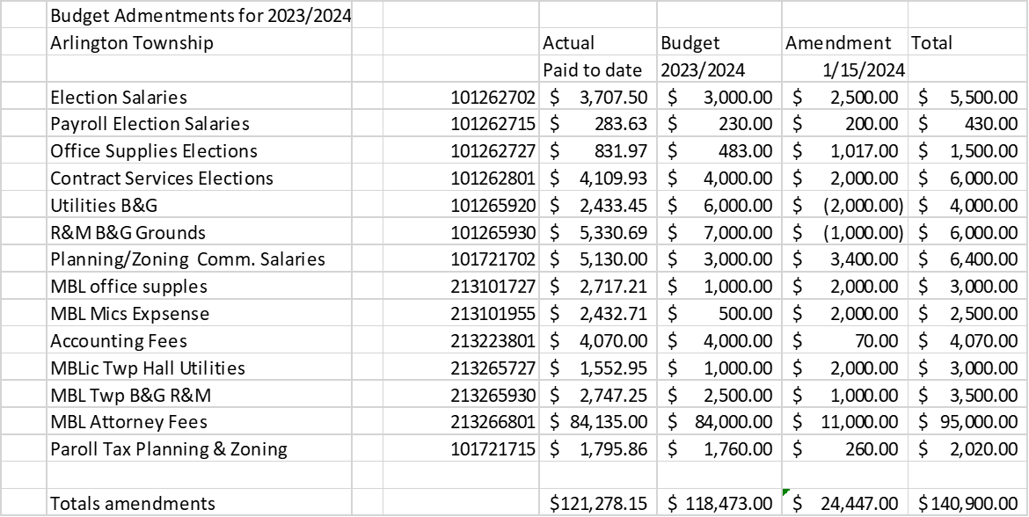

Clerks’ Report:
Treasurers’ Report:

New Business:
1. Planning Commission members attending MSU Citizens Planning Training on
March 12, 19, 26, April 9, 16, and 23, costing $250.00 per person. Payable out of Cannabis funding as it will help with future planning of Cannabis operations.

2. Declaration of Building and Use Restrictions for Hillside plat. Received from John O’Connell. Waiting on information from association: Organizational meeting minutes, meeting minutes, election of officers, dues, results of vote taken to adopt declaration. How many residents/members plat.

3. Adoption of Mining and Mineral Extraction Ordinance.

4. Bloomingdale Communication fiber optic installation discussion.

Adjournment:

